Spelling Menu
Directions: Choose a different activity each night (Monday through Thursday) for your spelling homework. Make sure your words are spelled correctly and take the time to sound out each one. Please date and label your work. Your spelling tests will be on Fridays.

Ransom” Words  “Write” your words by cutting letters out of a newspaper or magazine and gluing the letters on a piece of paper to spell your words.  Example below.  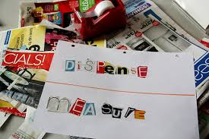 | ABC Order  Write all of your spelling words in alphabetical (ABC) order.  Example: book  choice  divide | Write your spelling words with colored pencils. Make each letter a different color.
Vowel Spotlight  Write your words using Blue for the vowels and Red for the consonants.  (vowels: a, e, i, o, u) | Sentences  Write 5 sentences using any of your spelling words. (words can be used only once) | Type your words  Type out your spelling words on the computer. Please print them out and turn in.
Picture words  Draw a picture and hide your spelling words in the picture.  Example below.  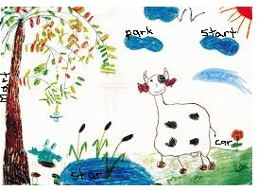 | Use Technology  Using a computer, type your words in a fun font three times  each. Please print them out and turn in.  Example: word, word, word | Pyramid Words  s  s p  s p e  s p e l  s p e l l  s p e l l i  s p e l l i n  s p e l l i n g

